21. Query to display Name, Hire Date and Day of the week on which the employee started.

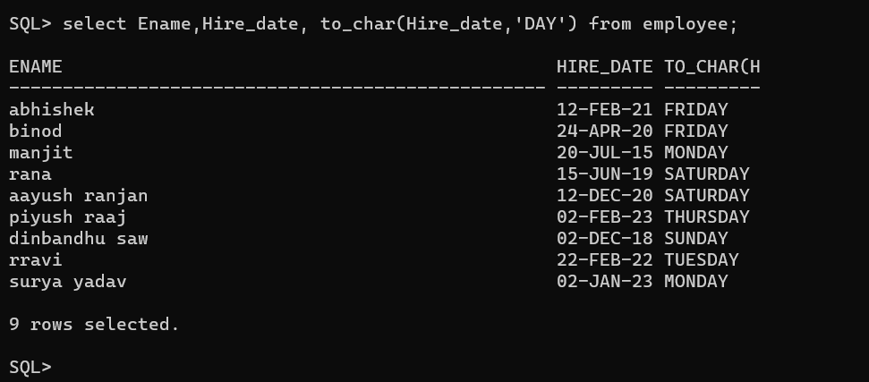

22. Query to display Name, Department Name and Department No for all the employees

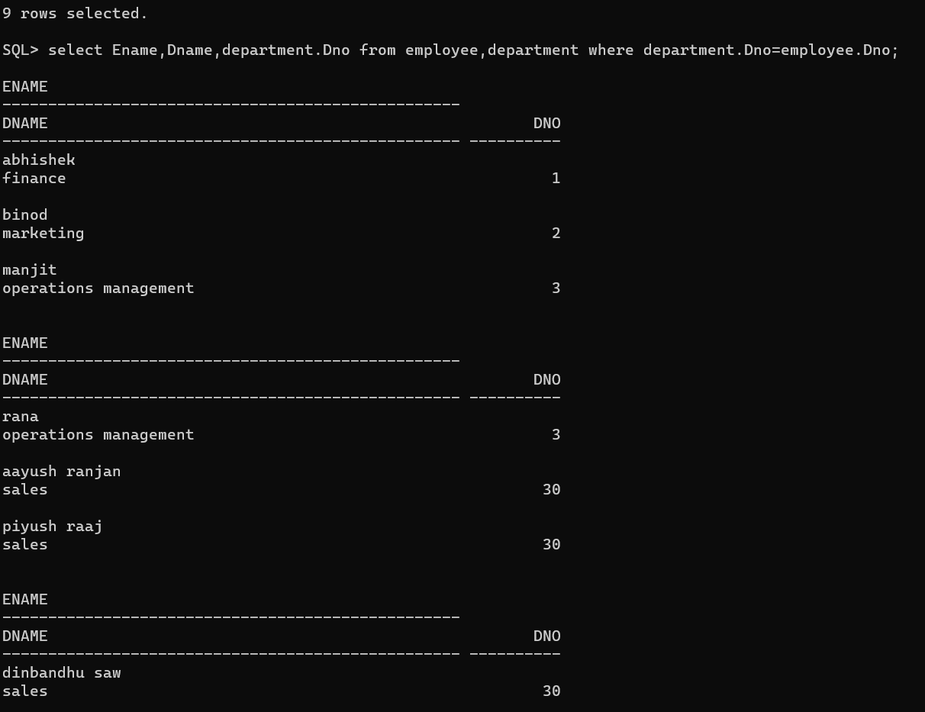

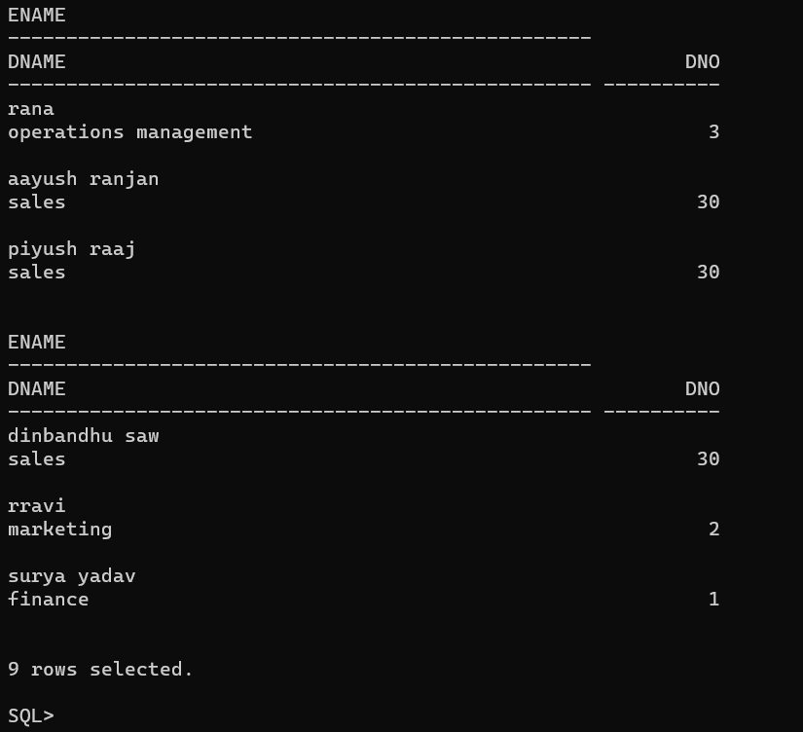

23. Query to display Unique Listing of all Jobs that are in Department number 30.

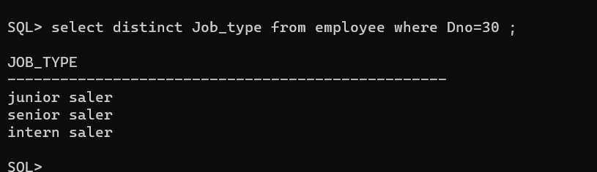

24. Query to display Name, Dept Name of all employees who have an ‘A’ in their name.

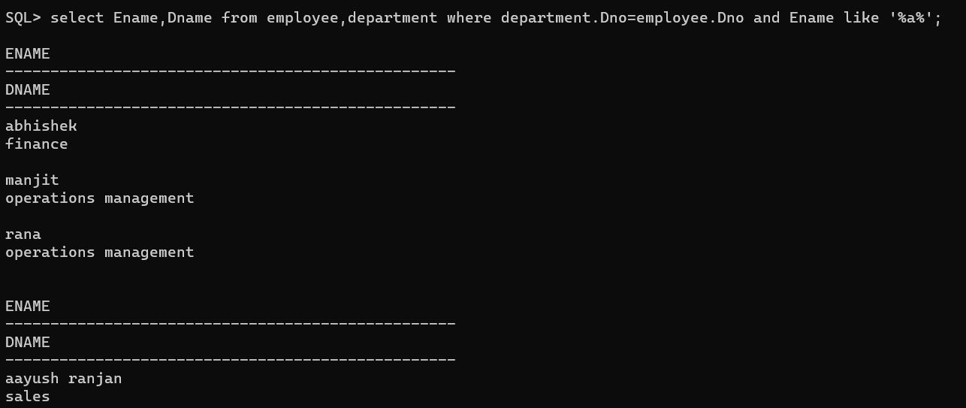

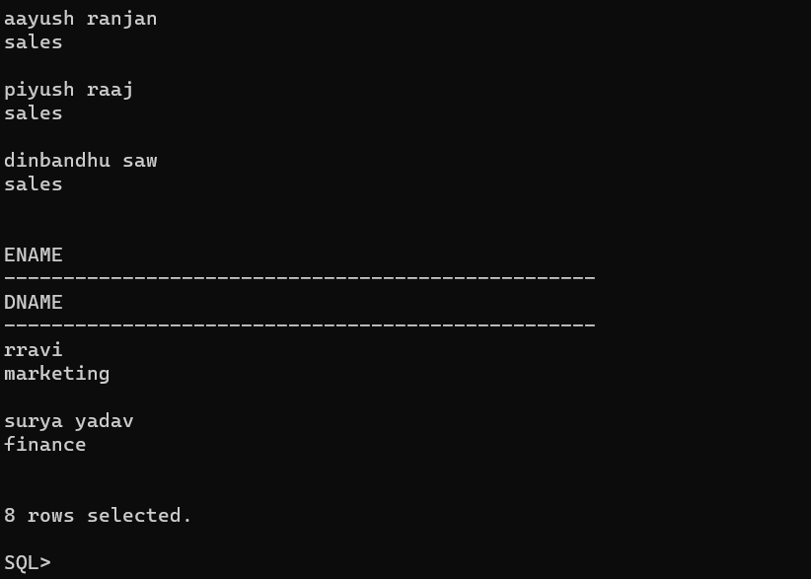

25. Query to display Name, Job, Department No. And Department Name for all the employees working at the Mumbai location.

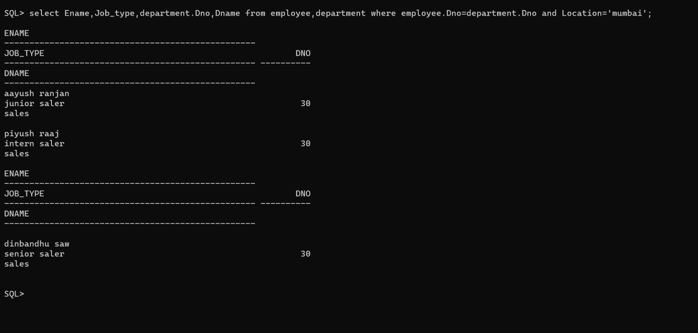

26. Query to display Name and Employee no. Along with their supervisor’s Name and the supervisor’s employee no; along with the Employees’ Name who do not have a supervisor.

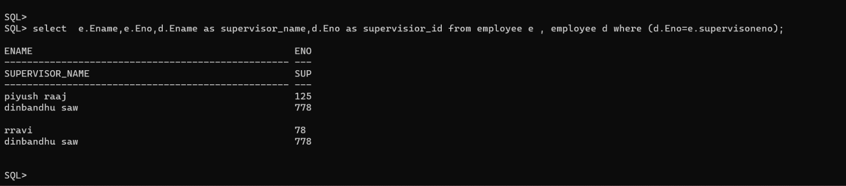

27. Query to display Name, Dept No. And Salary of any employee whose department No. and salary matches both the department no. And the salary of any employee who earns a commission.

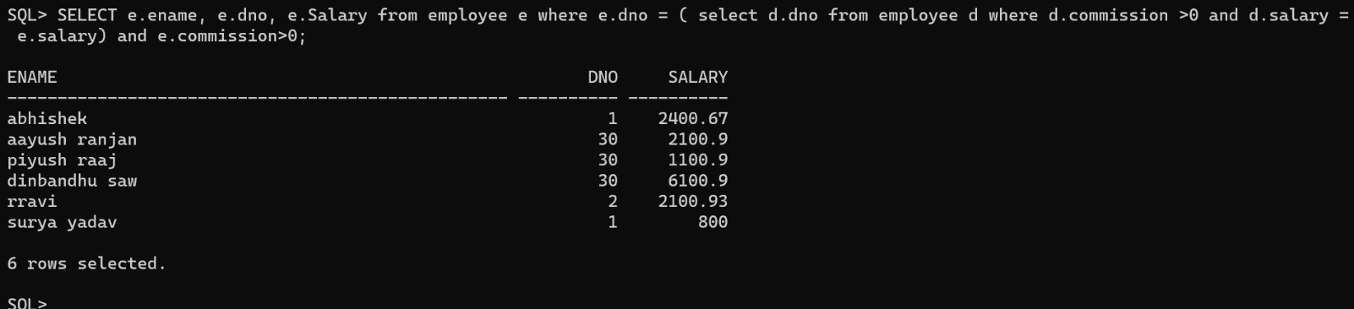

28. Query to display Name and Salaries represented by asterisks, where each asterisk (\*) signifies $100.

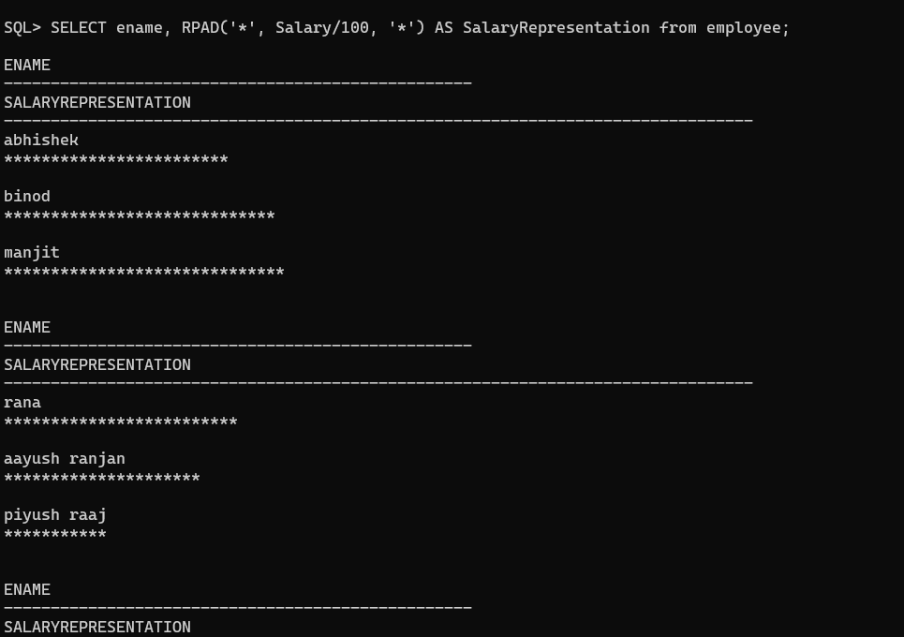

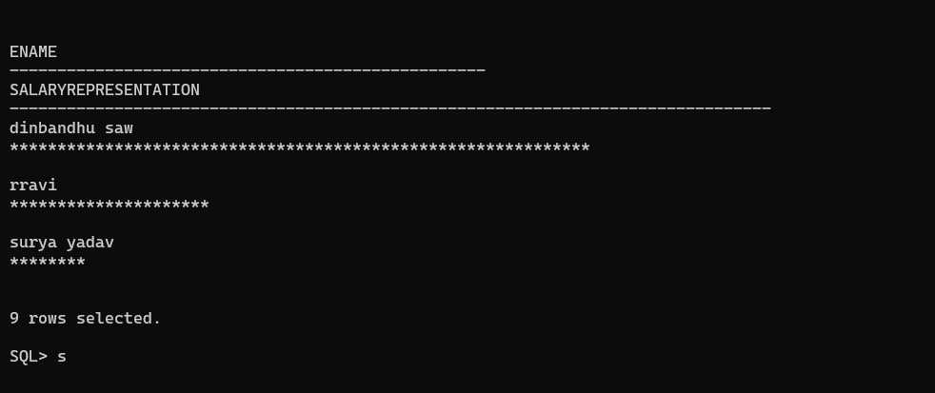

29. Query to display the Highest, Lowest, Sum and Average Salaries of all the employees

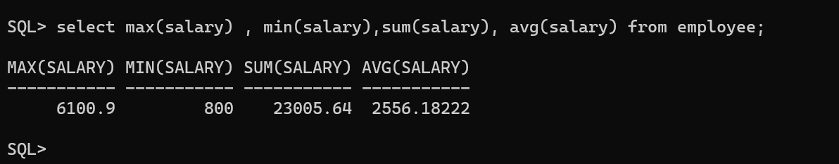

30. Query to display the number of employees performing the same Job type functions.

